In order to determine a limit, we must

Ex:  What is the domain?

1. Let *x* approach 1 for values less than 1:

|  |  |  |  |  |  |  |  |  |  |
| --- | --- | --- | --- | --- | --- | --- | --- | --- | --- |
| *x* | 0 | 0.5 | 0.75 | 0.8 | 0.9 | 0.95 | 0.99 | 0.995 | 0.999 |
|  | 1.0000 | 1.875 | 2.7344 | 2.9520 | 3.4390 | 3.7099 | 3.9404 | 3.9701 | 3.9940 |

What happens to the values of *f(x)*?

Notation:

1. Let *x* approach 1 for values less than 1:

|  |  |  |  |  |  |  |  |  |  |
| --- | --- | --- | --- | --- | --- | --- | --- | --- | --- |
| *x* | 1.001 | 1.005 | 1.01 | 1.05 | 1.1 | 1.2 | 1.25 | 1.5 | 2 |
|  | 4.0060 | 4.0301 | 4.0604 | 4.3101 | 4.6410 | 5.3680 | 5.7656 | 8.1250 | 15.0000 |

What happens to the values of *f(x)*?

Notation:

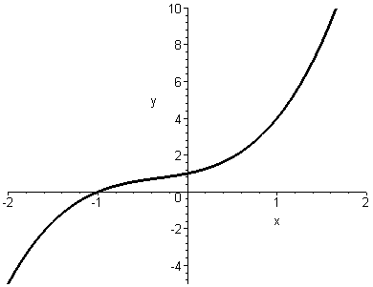

Ex:

**(a).** 

What is the domain?

Find 

**(b).** 

What is the domain?

Find 

**(c).** 

What is the domain?

Find 

**Note:**